District Profile
District | Agra- Leather Unit
Facts About the District | History- The golden age of the city began with the Mughals. Previously known as Akbarabad, Agra was the capital of the Mughal Empire under the Mughal Emperors Akbar, Jahangir and Shah Jahan. Babur, the founder of the Mughal dynasty, laid out the first formal Persian garden.
 | Location- Agra is a city on the banks of the river Yamuna in the northern state of Uttar Pradesh, India. It is 378 kilometers west of the state capital, Lucknow, 206 kilometres south of the national capital New Delhi. The Agra district is divided into Six Tehsils and 15 Blocks. Total number of Nayay Panchayats in the district is 114 while Gram Sabhas stands at 695.
 | Population- The current metro area population of Agra in 2020 is 2,210,000, a 2.31% increase from 2019.
 | Cultural Heritage- Near the gardens of Taj Mahal stands the important 16th-century Mughal monument known as the Red Fort of Agra. This powerful fortress of red sandstone encompasses within its 2.5-km-long enclosure walls, the imperial city of the Mughal rulers. The forbidding exteriors of this fort hide an inner paradise. There are a number of exquisite buildings like Moti Masjid - a white marble mosque akin to a perfect pearl; Diwan-E-Am, Diwan-E-Khaas, Musamman Burj - where Mughal Emperor Shah Jahan died in 1666 A.D. Jahangir's Palace, Khaas Mahal and Sheesh Mahal. Agra Fort, an excellent example of Mughal architecture, is one of the few UNESCO World Heritage Sites in India.
 | Name- Hindi word agar meaning salt-pan, a name which was given to it because the soil in the region. Sikander Lodi selected the site and named it Agra.
Tourist Places-
- Taj Mahal- The Taj Mahal is an ivory-white marble mausoleum on the southern bank of the river Yamuna in the Indian city of Agra.

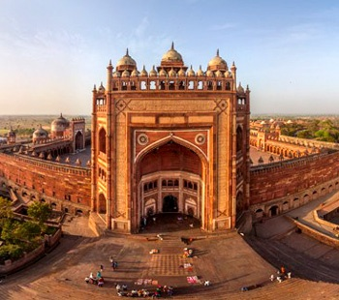
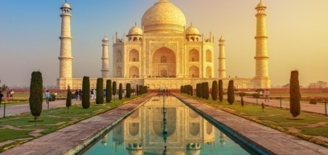
- Fatehpur Sikri- Fatehpur Sikri is a town in the Agra District of Uttar Pradesh, India. The city itself was founded as the capital of Mughal Empire in 1571 by Emperor Akbar.

- Ram Bagh &Mehtab Bagh- T he Garden complex, situated on the opposite bank of the Taj Mahal, is known as Mehtab Bagh, or “The Moonlight Garden”.

- Agra Fort- Akbar’s fort- Agra Fort is a historical fort in the city of Agra in India. It was the main residence of the emperors.

- Bird watching at Chambal River- Chambal River for Indian Skimmer, River and Black-bellied Terns and River Lapwing. Pipits, larks and birds of prey are often seen on the sandy bank. Gharial and Marsh Crocodiles are a certainty, often permitting close views.

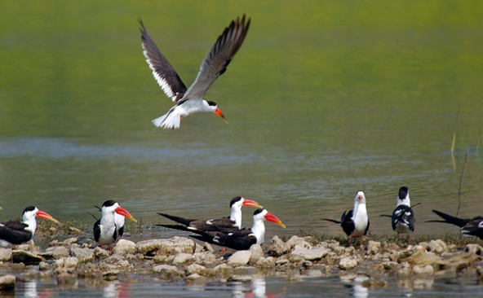
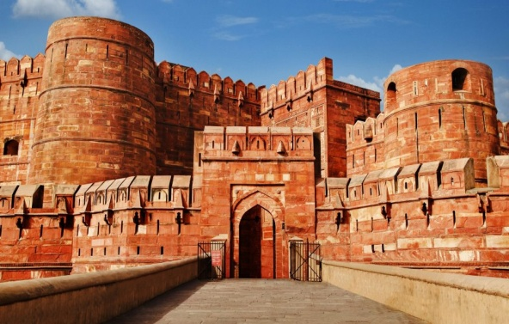
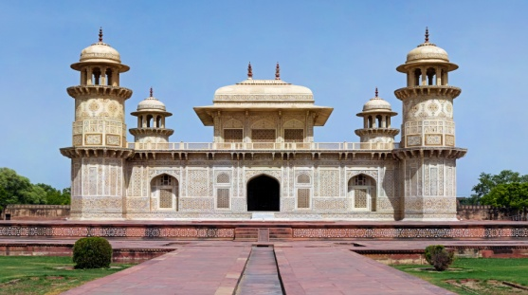

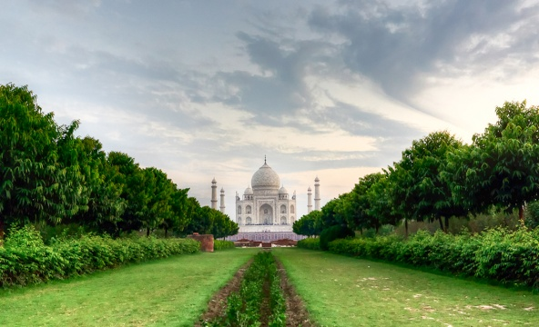
- Itmad-ud-Daula- Nicknamed the Baby Taj, the exquisite tomb of Mizra Ghiyas Beg was the precursor to the Taj Mahal. Built between 1622 and 1628, it is located along the banks of the Yamuna and was built by the Mughal queen Noor Jahan, wife of Emperor Jehangir, to commemorate her parents.

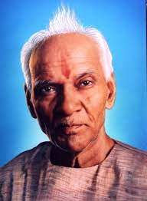
Five important/famous person (poet, cultural artist, freedom fighter)-

- Pandit Shriram Sharma Acharya- Founder of All World Gayatri Pariwar. He is the spiritual head and founder of All World Gayatri Pariwar, which has its headquarters at Shantikunj, Haridwar. He was a great social reformer, a prominent philosopher and a visionary .

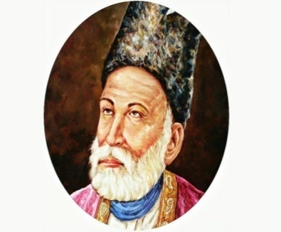

- Mirza Asadullah Khan Ghalib- Mirza Asadullah Khan Ghalib was born in Agra on December 27, 1797. He is considered to be the brightest star shining in the sky of Urdu and Persian poetry. Diwan-i-Ghalib is the most known book of Urdu poetry till today.

- Motilal Nehru- Motilal Nehru (6 May 1861 - 6 February 1931) ,born in Agra, was the president of Indian National Congress twice. He was a leading lawyer and a freedom fighter. Gave birth to the famous Nehru-Gandhi dynasty which saw 3 prime ministers of India.


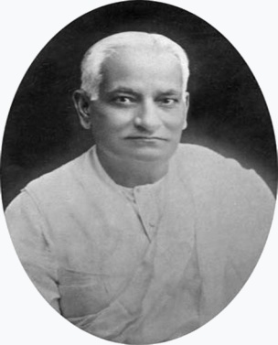

- Nimmi- Nimmi was a popular Indian actress in the 1950s and early 1960s in Hindi films. Originally named Nawab Banoo,she was born in Agra. She worked with top heroes like Raj Kapoor (in Bhanwara), and Dev Anand (in Sazaa, Aandhiyan) and Dilip Kumar(in Deedar and Daag )

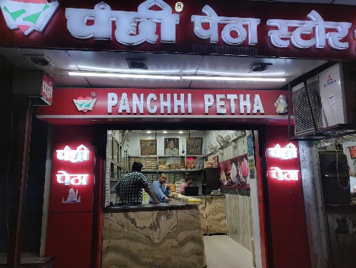
Five famous eating/selling items- The Mughal dishes are extremely famous here-

- Petha- Panchipetha store, Agra famous petha
The year was 1950 A workaholic young man of 24 years Late Shri Pancham Lal Goyal Ji (Nickname Panchhi) came forward. Confident at heart & dreams in his eyes to change the manufacturing and marketing scenario in this trade. He started the ground work and gradually gave it a shape and thus emerged- PanchhiPetha, the name that changed the concept of conventional selling in this trade.
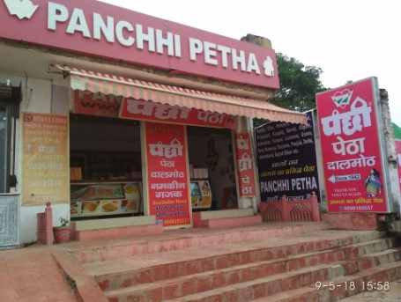
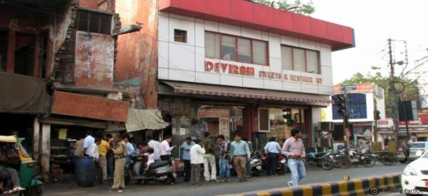

- Dalmoth- Pnachi pethadalmoth store- Panchhi Petha was established by Late Shri. Panchhi Lalji, more than 70 years before. Initially it was started with one single shop.

- Bedai- Deviram sweets- One of the oldest and famous sweet shops of Agra. Basically this shop is famous for it's tasty delicious bedai kachori.
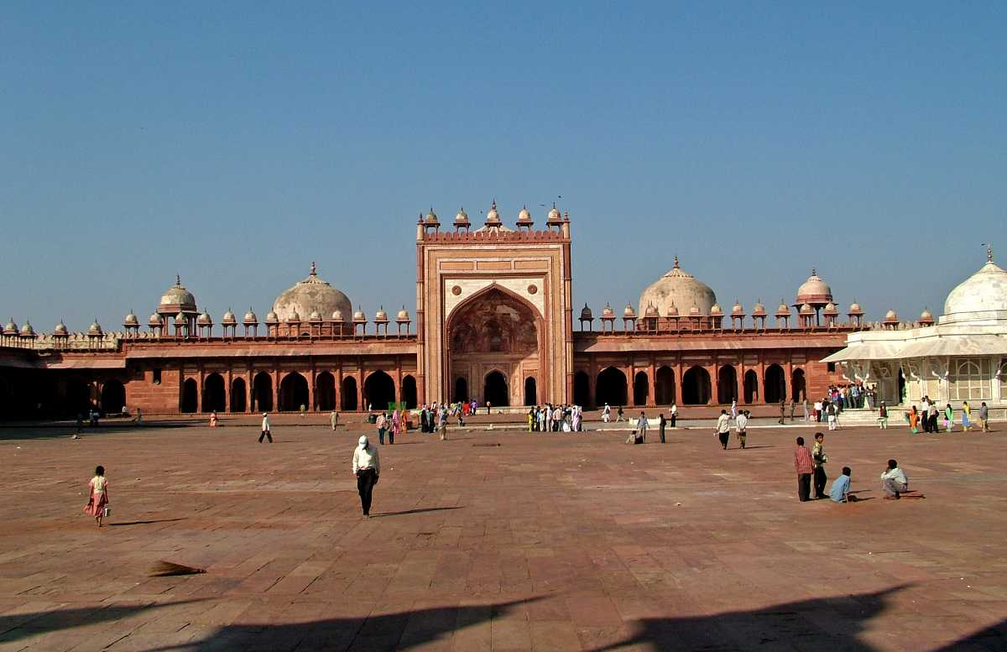
Religious Place-
- Jama Masjid- originally named Masjid Jahan Numa, built by Shah Jahan dedicated in the name of his daughter Jahanara Begum. The premises of the south minaret are 1076-sq-ft wide where 25,000 devotees at a time may sit together for namaaz (prayer). It is said that Emperor Shahjahan built Jama Masjid at the cost of Rs. 10 crore and it can be called as the replica of Moti Masjid in Agra.

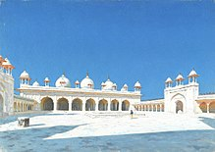
- Moti Masjid- The Moti Masjid was built by Emperor Shah Jahan (r. 1628-1658) at the highest point in the Agra Fort complex. It was completed in 1655, taking seven years to build. The mosque sits on a platform, and consists of a large courtyard surrounded by continuous arcades and a prayer hall.

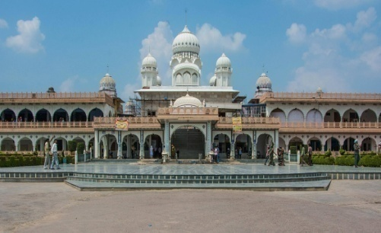
- Guru ka Taal- Guru ka Tal is a historical Sikh pilgrimage place dedicated to the memory of ninth Guru Sri Guru Tegh Bahudar Ji. Guru ka Taal is near Sikandra in Agra.

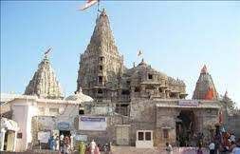

- Bageshwarnath Temple- Bageshwarnath Temple is located in Agra. It’s a very peaceful, devotional and Spiritual place.

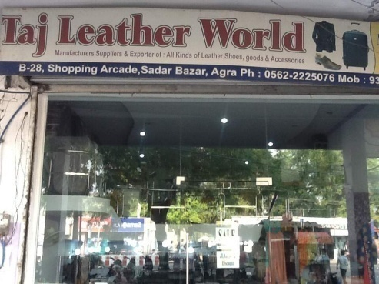
Five ODOP outlets-
- Taj Leather World- Taj Leather World is a great option to buy good quality leather products at good decent prices. They have good variety of shows for gents (though very little options for ladies. It is located right in the middle of sadar bazar and cannot be missed; one can definitely find something or the other for themselves.


- HAYST- Manufacturers,Exporters, of Leather Belts, Ladies Hadbag, Mens Lapctop Bag offered by HAYST from Agra, Uttar Pradesh, India.

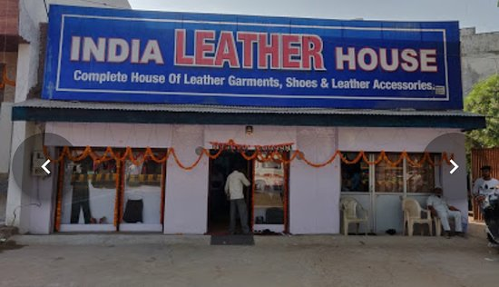

- India Leather House- All INDIA Leather House in Fatehabad Road, Agra is one of the leading businesses in the Leather Bags.

Famous Product other than ODOP -
- Pietra Dura
- Marble Inlay
- Carpets
- Petha
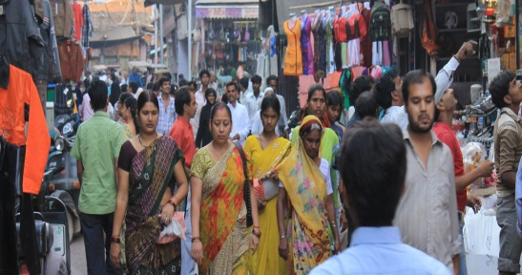
Famous shops/Markets-
- Sadar Bazar- Sadar Bazaar is a popular shopping destination for tourists visiting Agra. It is located close to Agra Cantonment railway station and is in proximity to the Taj Mahal.

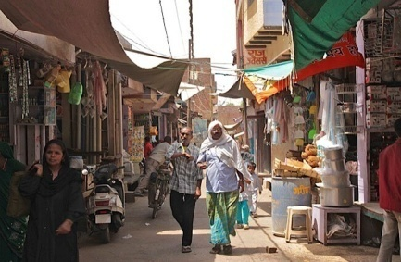
- Taj Ganj Area for food- Hub for food to binge in Agra

Five ODOP product manufacturing places/units-

S.No. | Shop name | Person Name | Phone No. | E-mail | Address | Pincode | Product Name | Price | Product Image
1. | Ganga Leather Enterprises |  |  |  |  |  |  |  | 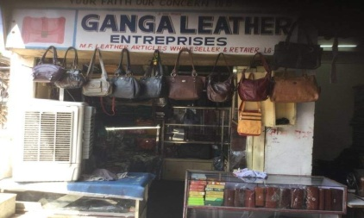
2. | Suede Leather Manufacturers
3. | Shameen International
4. | Taj Leather World
5. | Virola International

